**Base Station Assembly Guide**

**Rev 1.0 – RG – 22nd May 2015**

**Parts**

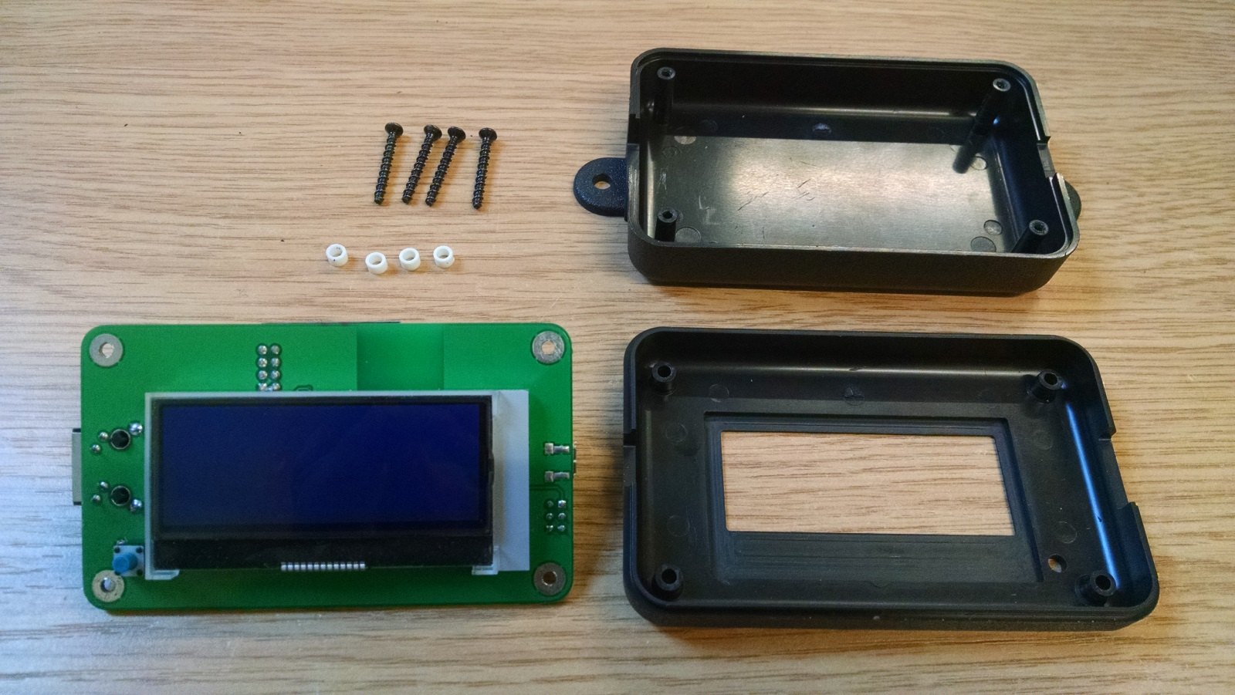

**C**

**A**

**B**

**E**

**D**

**A – 4x Screws 4x1 Black thread forming (BOM item 30) – Customer supplied.**

**B – 4x Spacers M3 NYLON 3MM (BOM item 31).**

**C – 1x Assembled PCB.**

**D – 1x Enclosure base (BOM item 29) – Customer supplied.**

**E – 1x Enclosure lid (BOM item 29) – Customer supplied.**

**Step 1 –** With enclosure lid **E** face down, place assembled PCB **C** into enclosure lid **E**.

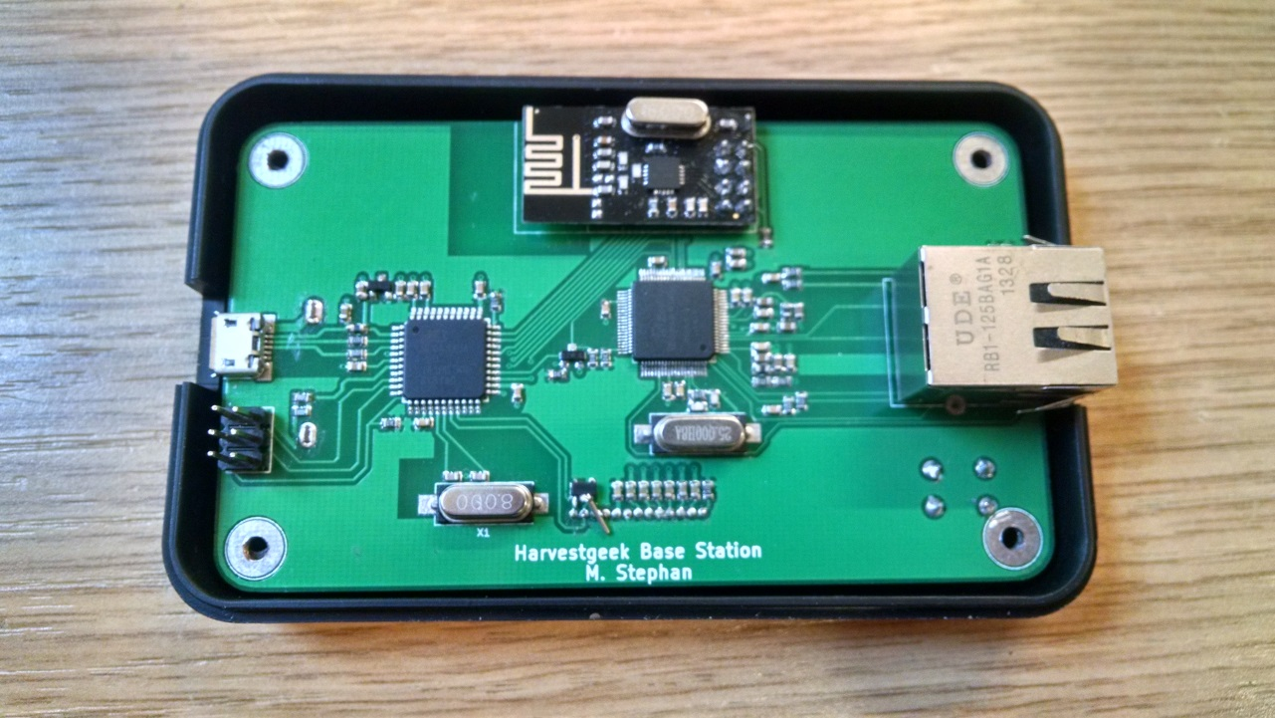

**Step 2 –** Insert screws **A** into enclosure lid **E** and through assembled PCB **C**.

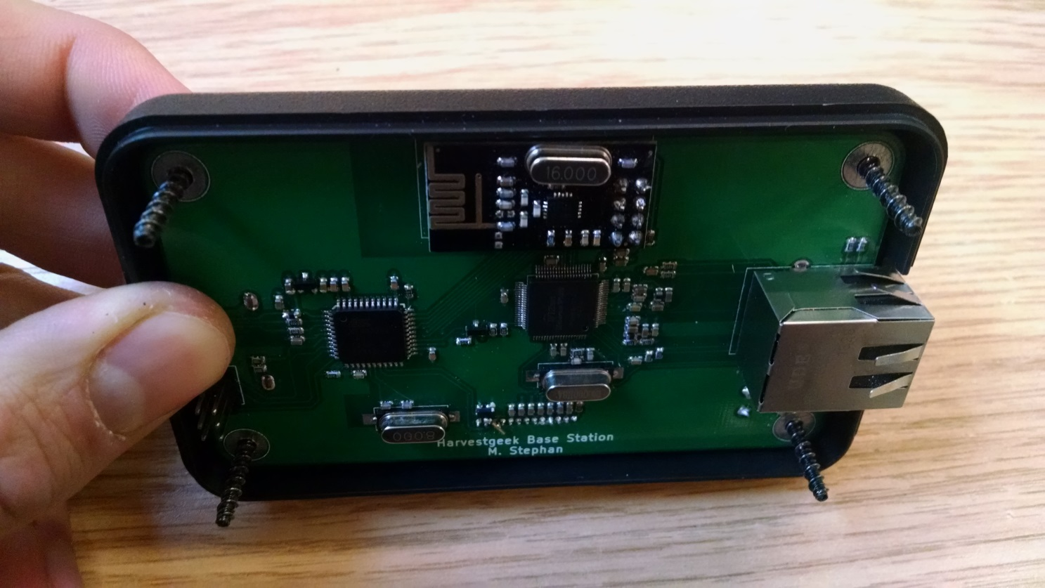

**Step 3 –** Lay back face down and place spacers **B** on to screws **A**.

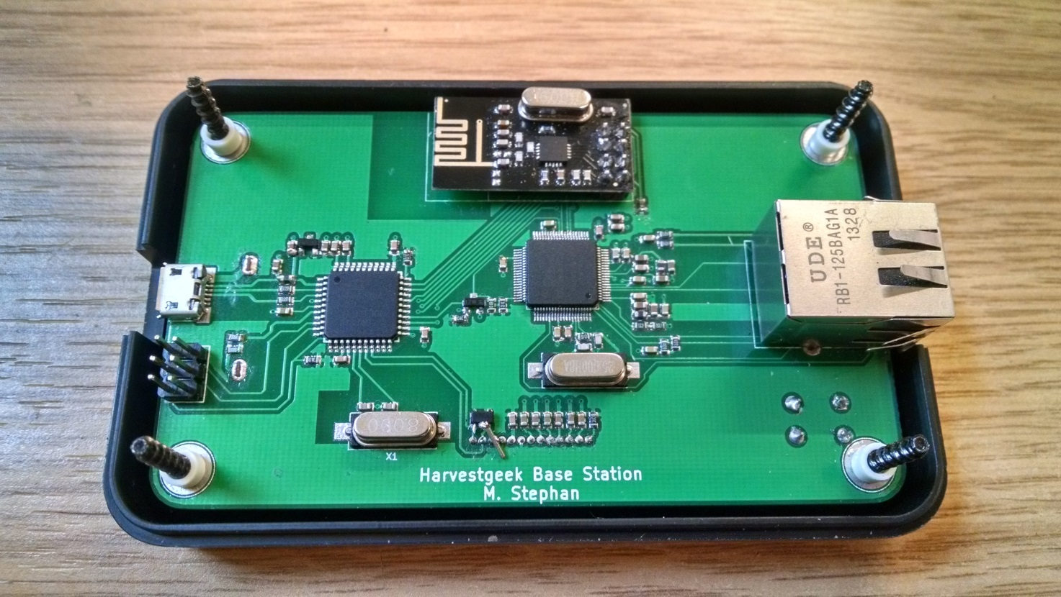

**Step 3 –** Place enclosure base **D** face down, on to the screws protruding enclosure lid **E**.

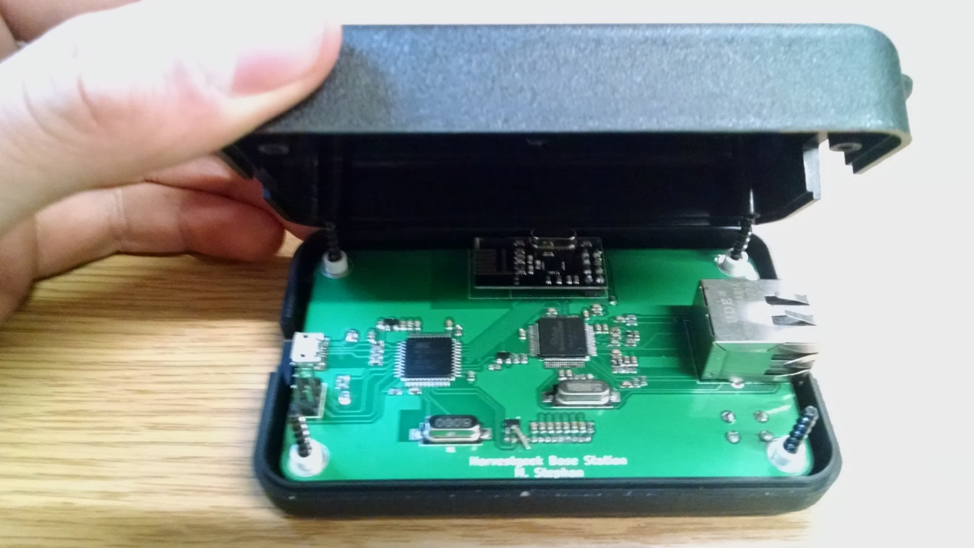

**Step 3 (continued)**

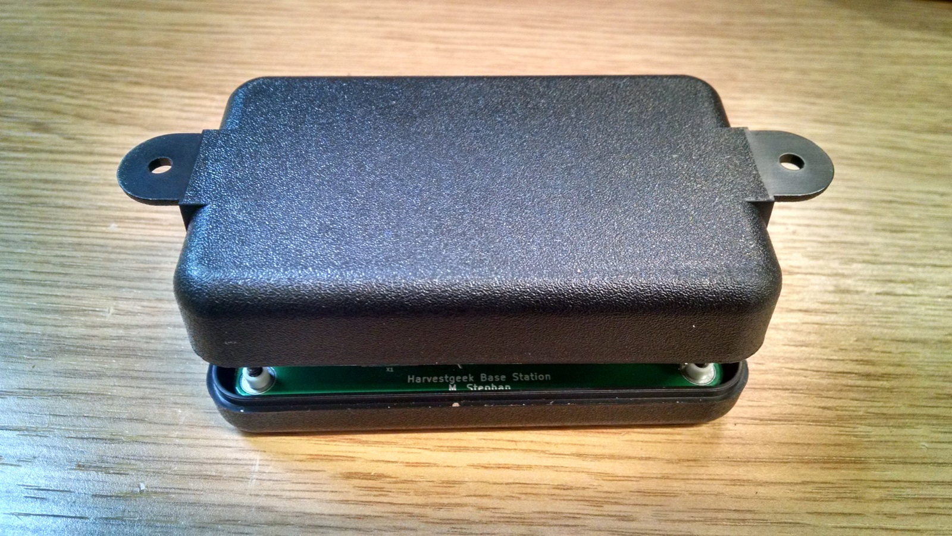

**Step 4 –** Carefully flip entire assembly over, so the enclosure base **D** is on the bottom.

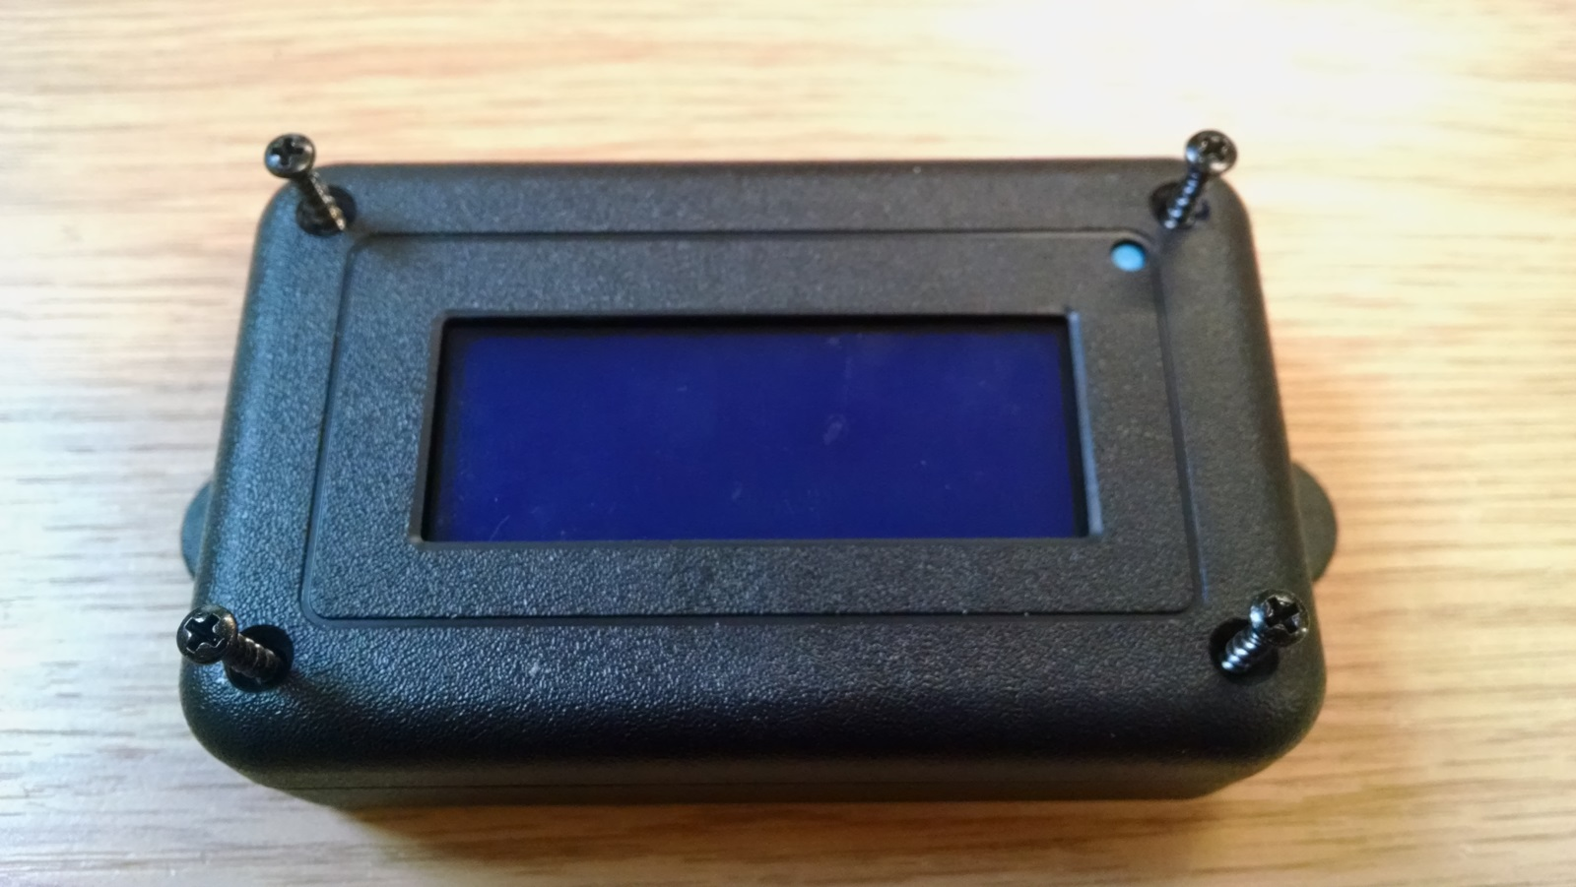

**Step 5 –** Screw in all four screws **A** until tight. Enclosure manufacturer recommends torque of 4 lbs.in.

**Assembly complete.**